**Report: Implementing a Dynamic Product Listing Component**

**Mehdi Abbas - 461734**

**Objective:**

The primary objective of Day 4 is to design and develop **dynamic frontend components** that can display marketplace data fetched from **Sanity CMS** or external APIs. This process focuses on modularity, reusability, and applying real-world development practices to build scalable and responsive web applications.

# Task Overview

**Objective:**

Build a **Product Listing Component** for a marketplace.

**Requirements:**

1. Fetch product data dynamically using Sanity CMS or an external API.
2. Display the data in a **grid layout** of cards with the following details:

* **Product**
* **Name**
* **Price**
* **Image**
* **Stock**

1. Ensure responsiveness across devices.
2. Implement modularity by breaking the component into smaller, reusable parts.

**Tools & Technologies:**

* **Framework:** React or Next.js
* **CMS:** Sanity CMS
* **Styling:** Tailwind CSS or plain CSS
* **State Management:** React Hooks

# Implementation Plan

1. **Set Up Data Fetching:**
   * Integrate Sanity CMS or API endpoints to fetch the product data dynamically.
   * Use React hooks (useEffect) for data fetching and (useState) to store and manage the data.
2. **Design Reusable Components:**
   * Break down the Product Listing Component into smaller parts:
   * **Product Card Component:** Displays individual product details.
3. **Apply Responsive Design:**
   * Use Tailwind CSS or CSS Grid/Flexbox to ensure the grid layout adapts to all screen sizes.
4. **Enhance User Experience:**
   * Highlight important details like stock status with conditional formatting. o Add hover effects for better interactivity.

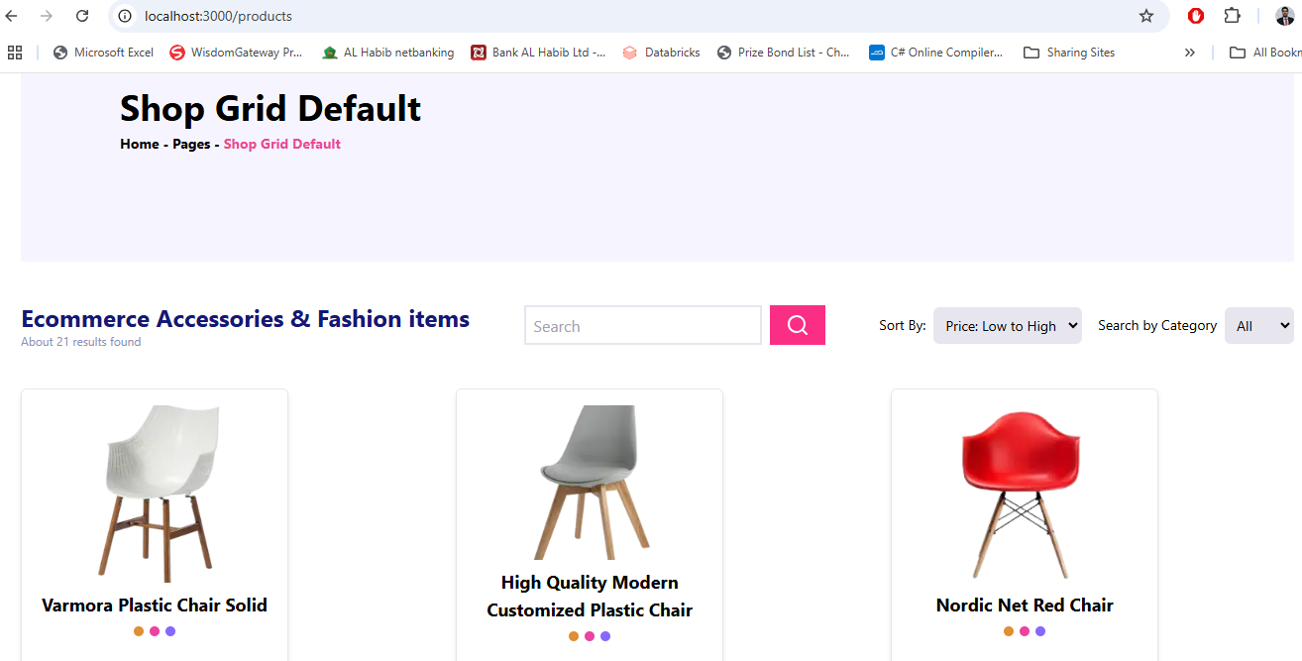

# Product Detail Component

**Objective:**

Develop individual product detail pages using **dynamic routing in Next.js**. These pages will display detailed information about each product, including:

* **Name**
* **Product Description**
* **Price**
* **Category**
* **Stock Availability Implementation Plan:**

1. **Dynamic Routing:**
   * Create dynamic routes using the [id].tsx file in the pages/products directory.
   * Fetch product data based on the product ID from a CMS like Sanity or an API.
2. **Data Fields:**

Each product detail page should include the following fields:

* + **Product Description:** A detailed explanation of the product, fetched from the backend.
  + **Price:** Displayed prominently for clear visibility.

1. **Integration with Product Listing:**
   * Link each product card in the **Product Listing Component** to its corresponding detail page using the Link component in Next.js.
2. **Styling and Layout:**
   * Use Tailwind CSS or plain CSS for a clean and responsive design. o Ensure the layout highlights the product description and price for user clarity.

***UI Display OF Product Detail Page:***

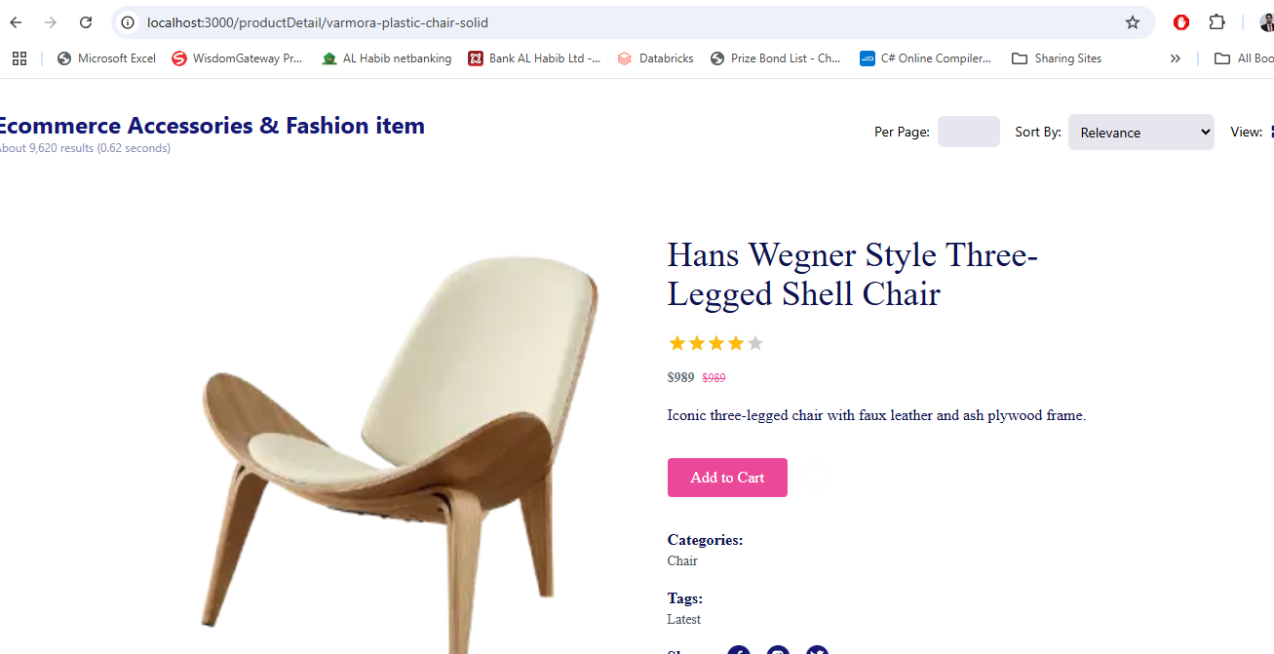

# Step 3: Search Bar with Price Filter

**Objective:**

To implement a **search bar** and **price filters** to enhance the product browsing experience.

**Implementation Plan:**

1. **Search Bar Functionality:**
   * Filter products based on their name or associated tags. o Update the product list in real-time as the user types.

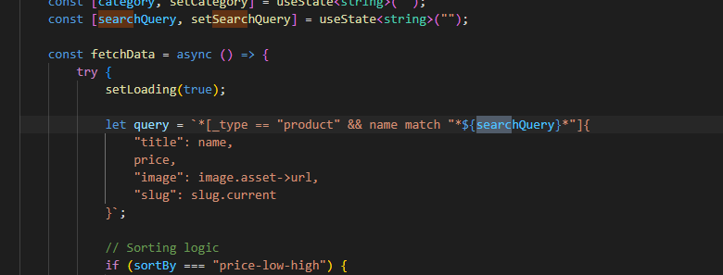

UI Display :

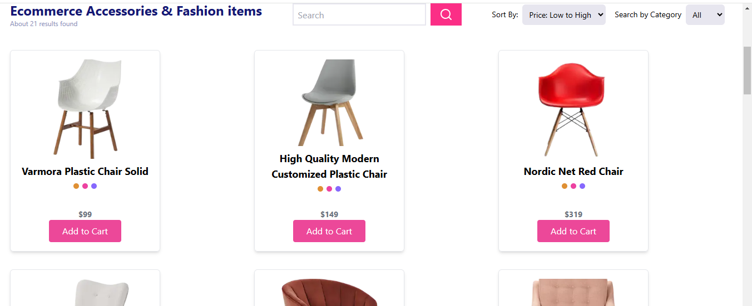

1. **Price Filtering:**
   * Add options to sort products by price in **ascending** or **descending** order.
   * Combine the price filter with the search bar and category filter for seamless interaction

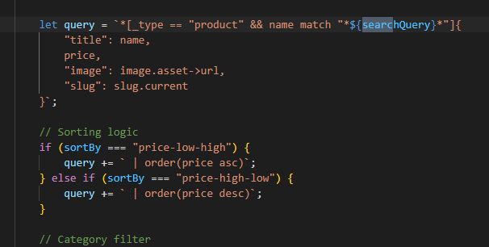

***UI Display:***

* ***High To Low:***

* ***Low To High:***



**Features Implemented:**

1. **Search Bar:** o Filters products by name or tags in real time.
2. **Price Filter:**

o Allows sorting products by price (low to high or high to low).

# Step 4: Cart Component

**Objective:**

To create a **Cart Component** that displays the items added to the cart, their quantity, and the total price of the cart dynamically.

**Implementation Plan:**

1. **Local Storage:** o Use **local Storage** to store cart data.
2. **Cart Data:** o Include details for each product in the cart:
   * + Product Name
     + Price
     + Quantity
   * Calculate and display the **total price** dynamically based on the items in the cart.

1. **Cart Interactions:**
   * Allow users to **increase or decrease the quantity** of items.
   * Automatically update the total price when the quantity changes.

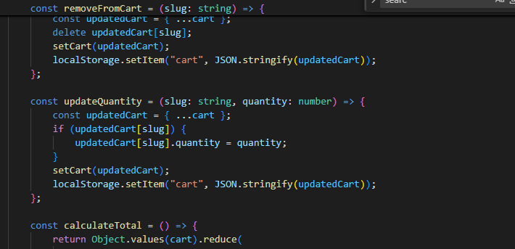

***UI Display Of Cart Page:***

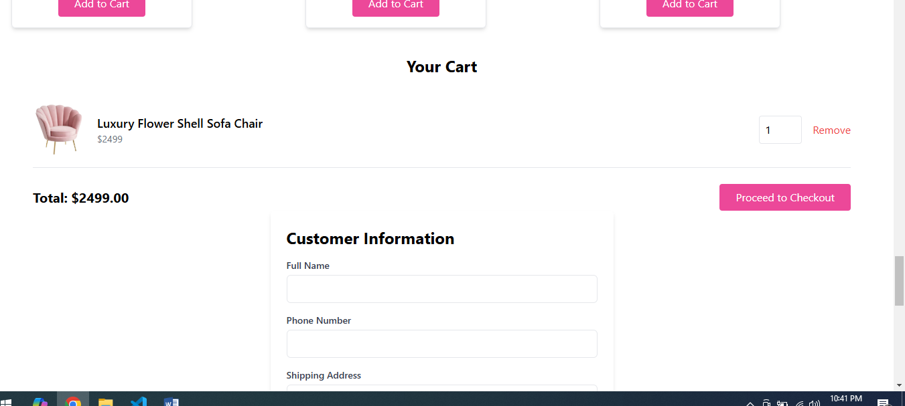

1. **Dynamic Item Display:** o Each item in the cart is displayed with its name, price, and quantity.
   * Subtotal for each item is dynamically calculated.
2. **Quantity Update:** o Buttons to increase (+) or decrease (-) the quantity of an item.
   * Quantity cannot go below 1.
3. **Total Price Calculation:**
   * The total price updates dynamically as items are added or quantities are changed.
4. **Remove Item:** o Users can remove individual items from the cart.

# Conclusion

On **Day 4** of building dynamic frontend components for a marketplace, the focus was on creating modular, reusable, and responsive components. The following key components were successfully implemented:

1. **Product Listing Component:**
   * Dynamically displayed products in a grid layout with details such as product name, price, image, and stock status.
2. **Product Detail Component:**
   * Built individual product pages using dynamic routing in Next.js, including fields like product description, price, and image.
3. **Search Bar and Filters:**
   * Implemented functionality to filter products by name or tags and added price filters (high to low and low to high).
4. **Cart Component:**
   * Displayed items added to the cart, quantity management, and total price calculation with dynamic updates.